Dear Sirs,

The difficult, not to say unacceptable, situation for stray dogs in Poland has been drawn to the attention of many people in Sweden. The Non-Governmental Swedish organization CHANS - CHarity for ANimals Society - is urging the proper Polish authorities to look into the situation with a special regard to some so-called dog-shelters. The latest example of maltreatment of dogs is the dog-shelter in Kielce. Poland is a member of the European Union. As such, it is the responsibility of the Polish authorities to see to it that the relevant EU directives regarding animal protection are adhered to.
It has also been brought to our attention that in Poland people are being paid for receiving stray-dogs. How are you following-up that these people take their responsibility and not only take the money for their own benefit?
We urge you to inspect the Kielce dog-shelter and see for yourself. We are looking forward to hear from you after your visit. Your prompt action in this matter would be much appreciated.

Sincerely yours,
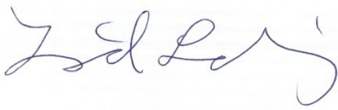
Ingrid Sunding
President,
CHANS - CHarity for ANimals Society
Wittstocksgatan 4
115 24 STOCKHOLM
ingrid@chanshund.com
SWEDEN

